

Paul D. Deeble
Premedical Sciences Advisor
120 Pearce Science Center
Mary Baldwin University
Staunton, Virginia 24401

(540) 887-7271
pdeeble@mbc.edu
TABLE OF CONTENTS

WHO IS MY ADVISOR? 3
HOW DO I CHOOSE A MAJOR? 3
COURSES OF STUDY 4
PRE-REQUISITE AND CO-REQUISITE COURSE REQUIREMENTS 4
GRADES and ENTRANCE EXAM SCORES 4
ADMISSIONS TESTS 6
HANDS-ON EXPERIENCE IN MY FIELD 7
FACTORS ADMISSIONS COMMITTEES CONSIDER 8
APPLICATION PROCESS 9
ADMISSION TEST 9
APPLICATION FORMS FOR THE PROFESSIONAL SCHOOLS 9
EVALUATION FORMS AND LETTERS OF RECOMMENDATION 10
SUPPLEMENTAL APPLICATION 11
THE PERSONAL STATEMENT 11
THE INTERVIEW PROCESS 11
FINANCING A PROFESSIONAL SCHOOL EDUCATION 12
ACADEMIC INFORMATION BY SPECIFIC PROFESSIONS 13
CHIROPRACTIC MEDICINE 13
DENTISTRY 14
MEDICINE (including allopathic and osteopathic) 15
NURSING – BSN 16
NURSING - MSN 17
OPTOMETRY 18
PHARMACY 19
PODIATRY 20
VETERINARY MEDICINE 21
STUDENT EVALUATION FORM 22
APPENDIX 23

This manual is intended for the undergraduate student who has aspirations to attend one of the many different professional schools in the medical sciences. It will inform you of the steps you will be taking during your undergraduate career at MBC to facilitate your acceptance into professional school later. You will find information on how to contact the Premedical Sciences Advisor, courses required and recommended by the various disciplines, how to arrange your schedule to meet deadlines, and other information pertinent to your challenges ahead. However, this is only a guide. All of the careers listed offer multiple schools to which you may apply (see Table 1 in the Appendix), and although each career discipline has minimal standard course requirements each school may have slight differences in their own requirements. Therefore, it is incumbent upon you to do research into your chosen field, identify the schools you want to apply to, and then identify the requirements for each school. Knowing these details will aid you and your academic advisor immensely when trying to arrange your 4-year plan.

WHO IS MY ADVISOR?
You will likely have two advisors at the same time. As a freshman, you will have been assigned an advisor by the University. This person may not be in a specialty area related to your intended career. However, this person will be your academic advisor and is highly qualified to handle all aspects of your advising early in your academic career. At the same time, however, you should contact the Premedical Sciences Advisor for the University. This advisor will be responsible for assisting you through the laborious application and reference letter process while serving as a resource for you regarding any questions you have as you prepare for medical school. In addition, this advisor maintains contact with many professional schools, knows their general requirements, and can provide helpful hints along the journey. It is imperative that you come to know this advisor early in your academic life. Once you have chosen a major, you will be advised by a faculty member within the major’s department who is knowledgeable about the requirements of the major. It is not necessary that the Premedical Sciences advisor be your academic advisor, but it is important that you continue to maintain a productive relationship with the Premedical Sciences Advisor who will coach you along through your academic career to ensure that you are aware of all of your options in the health-related professions.

HOW DO I CHOOSE A MAJOR?
Pre-Medicine/Dentistry/Pharmacy/Optometry/Osteopathic/Podiatry/Veterinary Medicine/Chiropractic Medicine etc.
At most universitys and universities, including MBC, pre-medicine/pharmacy/dentistry, etc., are not actual majors, but career intentions. Students who wish to enter one the above professions are expected to declare a discipline-based major. However, it is important for us to know which of our students are interested in a medical sciences profession. We want to ensure that these students receive appropriate academic counseling and that they have access to necessary information and resources. Most professional schools require the students they admit to have completed a four-year degree prior to entry into their program. Although many Premedical Sciences students do major in biology or chemistry (and these are excellent majors!), a growing number of candidates admitted to professional school completed a degree in a non-science major. Even our new Health Sciences major was not really designed with traditional pre-med/allopathic students in mind. Regardless of the major, students admitted to professional school excelled academically, including in the prerequisite science courses, and earned competitive entrance exam scores. We recommend students select their major based on interest and ability. Professional school admissions committees regard well-rounded students very highly. The most critical factors to admissions committees when considering candidates for acceptance to their programs are the student’s academic performance, entrance test scores, and what is sometimes referred to as the “X-factor,” comprised of issues revolving around commitment, motivation, leadership ability, community service, and work experience.

You are strongly encouraged to consult with the Premedical Sciences Advisor whenever you feel he can be of assistance. Working with your academic advisor, you should create a curriculum that will satisfy all of the prerequisites for your chosen field in the medical sciences as well as take courses that will lead you to an alternative career should you not be accepted to the professional school of your choice. Whatever course of study you choose, it is recommended that you follow a rigorous curriculum, particularly rich in biology, chemistry, physics, and mathematics, and that you do as much upper-level course work within your major as possible to demonstrate depth of understanding.

COURSES OF STUDY
Like all other students, you will need to complete your basic studies requirements, the required courses for your major, and free elective hours to total the 126 hours needed to graduate from MBC. Since almost all health professional programs are now at least Master’s level academically, you will likely be spending four years here before going on to a professional school. Most medical professions schools, like medical schools, expect you to graduate from university before attending. Some programs, like pharmacy, allow you to apply in your sophomore year, then move to their programs for another four years leading to a doctoral degree. For these reasons it is imperative that you learn all you can about the programs that interest you and take the appropriate courses at the right times. Your advisor will be immensely helpful in this regard. In addition to courses required by the professional schools, there are other classes that are recommended. You should also try to work these into your program. On following pages you will find descriptions of the professional schools, matching their requirements with the matching courses on our campus. In the Appendix you will find a suggested curriculum to meet the needs of most of the health professional schools.

PRE-REQUISITE AND CO-REQUISITE COURSE REQUIREMENTS
Certain biology, chemistry, and physics courses require pre-and/or co-requisite classes. These are outlined in the Academic Catalog. It is the student’s responsibility to review this information and to discuss prerequisite requirements and course sequencing with the Premedical Advisor and/or the academic advisor in the student’s major

GRADES and ENTRANCE EXAM SCORES
In order to be competitive for admission to professional school, good grades are extremely important. Most professional schools require a minimum grade point average. Because of the high caliber of many of the applicants, students should realize that acceptance with only the minimum grade point average is highly unlikely. Take the time to look at the admissions criteria of the schools you wish to attend and at the median grade point average (GPA) and entrance test scores of the most recently admitted class of students (the entering class profile). This will give you a good idea of what your goal should be in regard to academic performance. Good study habits, time management and prioritizing skills are strong factors in earning good grades.

- Generally, professional schools consider science credits over three to five years old outdated.
- REPEATING/DROPPING COURSES: Most professional schools average together the first and all subsequent grades earned in repeated courses when calculating an applicant’s GPA. Dropping courses after the first week of classes should be avoided. More than a minimal number of repeats and withdrawals (at best) on a student’s academic record will be viewed with concern by professional school admissions committees. In the rare instance when it is justified to drop a class, it is imperative that the student show significant improvement when the course is completed. Students should select their class schedules carefully each semester, attend class on a regular basis, and keep up with and prepare well for the classes in which they are enrolled.
- MBC Medical School Acceptance Data: In 2015, the national acceptance average for all students who applied to medical school was 39%. The average GPA for students that matriculated to medical school was 3.70 (2015). Below are the data outlining the acceptance percentages (range is 1 to 10 applicants per year) and academic records for MBC students recently accepted to medical school. It will give you a good idea of what is required of students from MBC who wish to matriculate to medical school:

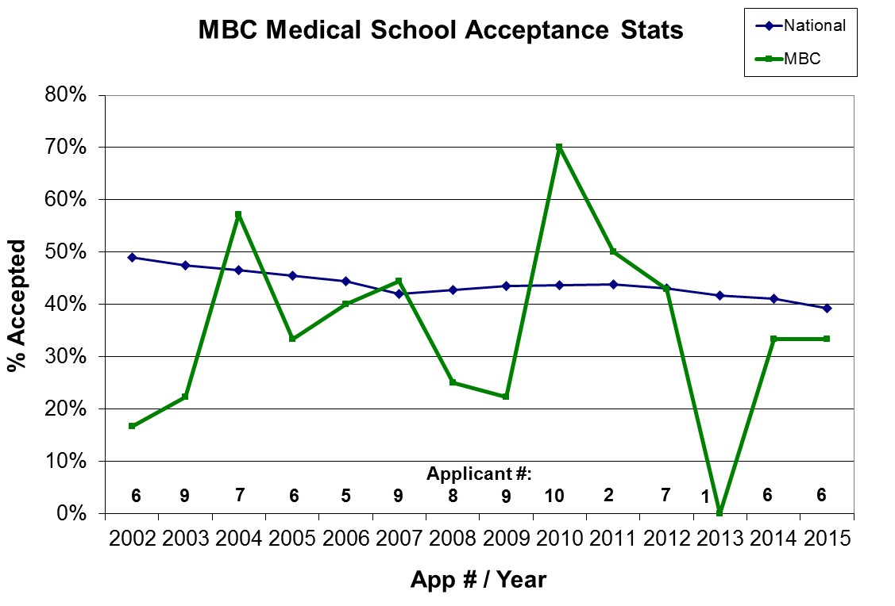
MBC Students Accepted to Medical School

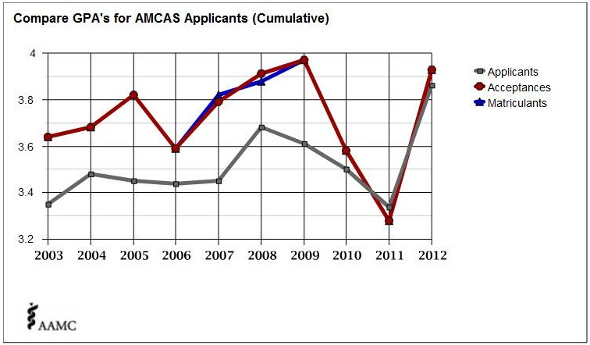
Average GPA for MBC Pre-Medical Students

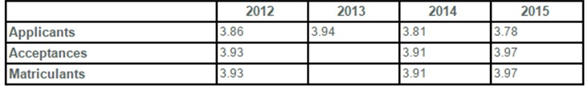

ADMISSIONS TESTS
Most health professional schools require that applicants take a standardized test and have their scores reported to the institution as part of the application procedure. In many instances the test score constitutes the most important part of the application dossier, because only through a standardized exam can fair comparisons be made between applicants from different undergraduate institutions. The tests are different for each health science profession:

- Dental Admission Test (DAT)
- Graduate Record Examination (GRE)
- Medical University Admission Test (MCAT)
- Optometry Admission Test (OAT)
- Pharmacy University Admission Test (PCAT)
- Veterinary University Admission Test (GRE)

In 2015, the national average of MCAT scores for students that were accepted to medical school was 29.6. Below are the data outlining the entrance exam scores for MBC students recently accepted to medical school. It will give you a good idea of what is required of students from MBC who wish to matriculate to medical school:

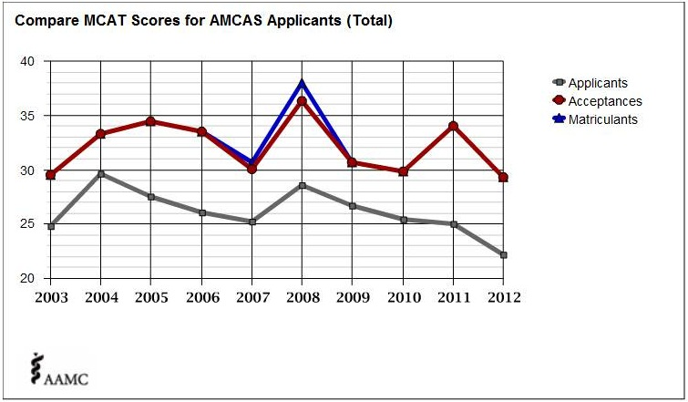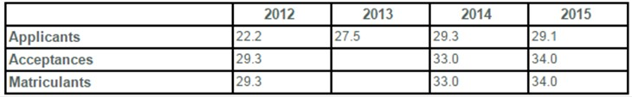
Average MCAT Scores for MBC Students

HANDS-ON EXPERIENCE IN MY FIELD
It is extremely important to obtain some first-hand knowledge of the field you hope to enter. Some medical and dental schools require documentation of 100 hours or more of experience related to your career field. However, you have neither education nor experience in the field so this can be difficult. If you are interested in pharmacy or veterinary medicine, you should try to get a job in the field working as a technician and accumulate as many hours as possible. The volunteer services department in your local hospital or your local free clinic are often great places to begin. Also, private medical practices that you might be familiar with in your area are good resources. Please work with the MBC Career Office if seeking placement for clinical shadowing in the MBC region. Professional schools are often more interested in seeing some level of altruism in their applicants. There are many places where a person can volunteer time and energy to the community. Be sure to make appointments to talk to representatives of organizations directly and mention that you are a Premedical Sciences student at MBC. Many organizations depend heavily on volunteerism, so treat volunteer work with the same dedication you would a paying job. At MBC, we have developed many customized internship experiences in collaboration with our students both locally and elsewhere in the United States. These career training experiences can be completed anywhere the students choose and appear as formal academic credit on their transcripts. For more information about getting experience, please talk to the Premedical Sciences Advisor.

FACTORS ADMISSIONS COMMITTEES CONSIDER
Professional schools do not routinely provide lists of criteria that must be met in order to be accepted, but the following factors are usually considered when assessing applicants:

- University grades, especially in those courses that are prerequisites for the school along with all science courses. In addition, how courses were taken, how many hours/semester, etc. are also considered when looking at the GPA.
- Admission test scores weigh heavily in the selection process because they give impressions related to what you have learned during your university experience and the likelihood for your success in the professional school curriculum.
- Indications of depth of understanding in your area of study, as evidenced by taking upper level courses beyond the minimum required for the major, special projects, research internships, and independent study.
- Strength in other intellectual qualities such as motivation, ease of comprehension, curiosity, retention of information, ability to generalize, extend, and apply knowledge, ability to deal with abstract ideas, breadth of interests, oral communication, and writing ability. The letters of reference that you will request from faculty should address these issues, so make sure your professors learn these things about you.
- Laboratory ability, including organization, efficiency, resourcefulness, and manual dexterity. Again, this is addressed in letters of reference.
- Evidence of strong interest and high achievement in non-academic pursuits and active participation (leadership roles) in extracurricular activities.
- Character and personal qualities such as integrity, responsibility, perseverance, leadership, ability to get along with others, self-confidence, consideration for and interest in others, emotional maturity, physical health, and personal appearance. Again, this is addressed in letters of reference.
- Sincere interest in your professional field and in helping people. This is usually evidenced by volunteer work in a health care setting over a period of several years.
- Awareness of current issues in the health sciences.
- Letters of reference that address many of the topics listed above. You should be aware that letters can rarely get you into professional school, but they can easily be used to keep you out. You want to be certain that you allow your professors to learn about you so that they can write informative and positive letters about you and your suitability for your chosen profession.

APPLICATION PROCESS

ADMISSION TEST
For most students, the admission test is taken in the spring semester of the junior year. Therefore, it is imperative that prerequisite courses necessary for the test be taken prior to the test date. It is your responsibility to know when the next admission test for your field is scheduled. When you are ready, obtain a test application package (on-line), be sure everything is completed correctly, and then meet the application deadline. The Premedical Sciences Advisor will have access to a copy of your scores. Scores are usually available from the testing service within 6 – 8 weeks after the test. Discuss your scores with the Premedical Sciences Advisor and devise a strategy for improving your scores, if necessary. Most test services will automatically send your scores to a set number of schools that you designated in the application process. If you request that more scores be sent, there will be an additional fee.

APPLICATION FORMS FOR THE PROFESSIONAL SCHOOLS
Soon after taking the appropriate admissions test, you should obtain forms for application to the health professional schools of your choice. It is your responsibility to know when the deadlines for these applications occur. For example, most medical schools use the American Medical University Application Service (AMCAS), and most dental schools use the American Association of Dental Schools Application Service (AADSAS). These are standardized primary applications that will be copied and sent to each of the professional schools you are interested in. Other professional schools may use an application service or the schools may have application packets available directly from them or their on-line site. The forms should be completed during the summer prior to your senior year or the year you intend to apply. These forms should be submitted as early as possible. Most professional schools have rolling admissions policies, meaning that the earlier your application is submitted, the more times an admissions committee can consider your file.

You should be very careful to complete all forms correctly and neatly. Typographical and grammatical errors make you appear uneducated and uncaring about details. Do not just rely on a spell checker and grammar checker. Find a good editor to read your essays (English professors and the Premedical Sciences Advisor can be invaluable in this regard). Be sure that you make no mistakes in transcribing grades and do not leave any grades out. You must send in official transcripts of all university courses taken even though your application may ask you to provide the information in writing. They will check between the two. Special attention should be given to any essays you are asked to submit. Use these opportunities to fill in any gaps in your application, to clarify a point that may be unclear from information given earlier in the application, or to offer an explanation for other things you feel the admissions committee should know. These essays should be meaningful and well written, but it should not simply provide what you think the admissions committee wants to hear. It will be crystal clear to admissions committee members when you are not writing from the heart. It will make them think of you in terms of insincerity and shallowness. These essays are extremely important to the admissions process. The essays are the major vehicle through which you can distinguish yourself from the thousands of other applicants to that professional school.

EVALUATION FORMS AND LETTERS OF RECOMMENDATION
At some point in the application process you will receive information regarding the submission of letters of reference (with your secondary applications for medical schools). In some cases these will be simple forms that the professional school gives you. In other cases, you will be asked to have a letter of recommendation sent on your behalf. It is your responsibility to make sure your referees know exactly what they are to do, deadline dates, and what the schools are looking for about you. Some schools will ask that you collect the recommendations from your referees and send them in as a packet while others will want the referees to mail the letters directly. The medical schools, in particular, may ask that a single composite letter of recommendation be sent from a Premedical Advisory Committee. In this case, you should have your referees send their letters (or forms) to the Premedical Sciences Advisor who will then write the composite letter as chair of the committee.

It is important for you to give careful consideration about whom you ask to write on your behalf. Rarely will a letter of reference get you into professional school, but they can work quite easily against you. You want people to write about your suitability for the profession, your academic prowess and the likelihood that you will be successful in the professional curriculum, etc. Professional schools want to gain insights about you. Therefore, choose referees who will write articulate and informative letters that provide concrete examples of why you are a good fit for your chosen profession. Do not wait to contact your referees until the request for a committee letter comes from a professional school. Your recommenders should be contacted as soon as you decide to apply to a professional school to give them ample time to submit your letters. The more time you provide for your recommenders, the more thoughtful a letter they can write on your behalf. A good timeframe for requesting a letter of recommendation is four weeks before you would like it submitted, remembering that you should double this time period when you need your recommenders to submit individual letters to the Premedical Sciences Advisor who then must write a committee letter of recommendation. Most professional schools will not consider your application until your letter(s) of recommendation are received.

A final thought about reference letters – almost all recommendations have a check-off box related to waiving your right to review the letters in your application package. Be sure to check one of the boxes and sign the form. You should give serious thought to waiving this right so that the admissions committee of the professional school knows that the letter of reference was an accurate reflection of you. Most faculty members will generally describe the type of letter they will write for you, but if you do not waive your access to that letter, some medical school admissions committees may assume that the faculty member writing the recommendation was not completely open about your strengths and weaknesses.

SUPPLEMENTAL APPLICATION
Some schools, particularly medical and dental schools, require a supplemental application after reviewing your initial application. This is usually considered a positive sign that you have cleared one hurdle in the application process. However, you need to realize that many more supplemental applications are requested than there are spaces in entering classes. The supplemental application should be completed with the same care as the initial application and should be returned promptly. Feel free to seek the help of the Premedical Sciences Advisor for support on these supplemental applications.

THE PERSONAL STATEMENT
Most professional schools require submission of a personal statement with the application. You can request copies of successful sample essays from the premedical Sciences Advisor. The Student Doctor Network offers an excellent free personal statement workshop at: www.studentdoctor.net/essays/index.asp

Avoid the cliché, “I want to help people,” although you can incorporate that theme into your essay by telling a story that distinguishes you from everyone else who has that same goal. Remember that the essay is the only personal means you have to present yourself to admissions committees prior to being invited for an interview. Use the statement to sell yourself and to differentiate yourself from other candidates, most of whom will have credentials similar to your own. Involve the reader from your first sentence. You are telling a story about yourself and want the lead character in your story – you – to emerge in an interesting and positive manner. Keep your essay well-organized and concise and make certain you have a strong closing statement. When addressing your accomplishments, do so within a context of gratitude. Explain any negatives, such as a poor grade, but stay positive and avoid criticizing your own school or blaming others for your own performance. Check spelling, punctuation and grammar, and have others critique your essay for grammar, clarity, content, and style.

THE INTERVIEW PROCESS
If after reviewing your application the admissions committee is still interested in you, you may be invited for an interview. In preparation for the interview you should know as much about the school as possible, think about the types of questions that you may be asked, and prepare mental/written notes of your responses. A workshop on interviewing skills is usually offered during the academic year by the Sena Center.

Seven common mistakes that occur at interviews and how to avoid them:
- Arriving late – allow more than enough travel time, acquire reliable and specific directions, and set two alarm clocks (just in case).
- Dressing informally – have a clean, conservative business suit ready to go.
- Poor eye contact – concentrate on maintaining eye contact throughout the interview. Eye contact is not the same thing as staring – engage in the conversation.
- Asking only self-serving questions – prepare questions that show your interest in the school.
- Demonstrating ignorance about the school – do some background work before the interview to demonstrate that you are a good match for their program.
- Using everyday language and speech patterns – practice interviewing and using professional terminology, where appropriate. Avoid such words as: “like,” “ya know,” “really,” and “OK?” when they are simply fillers.
- Failing to address the question asked – be careful to listen to the question and understand it before answering.

FINANCING A PROFESSIONAL SCHOOL EDUCATION
Health professional schools are generally expensive, with obvious greater expenses incurred at private schools. Most students finance their educations by relying on the availability of low cost student loans and then enter their first years as health care providers with a considerable amount of debt. Fortunately salaries usually are substantial enough to accommodate repayment of the loan within a few years (up to a decade after) of graduation. The Premedical Sciences Advisor has some information regarding sources of financial aid for health professional students, including options associated with the various branches of the military. The best sources of information are the Financial Aid offices of the professional schools themselves.

ACADEMIC INFORMATION BY SPECIFIC PROFESSIONS

Refer to the program sheets at the back of this manual for specific suggestions for your coursework here at MBC.

CHIROPRACTIC MEDICINE
Entry into a chiropractic school requires that you take the courses shown in the table below. Most schools do not require an admissions test. Usually two letters of recommendation are requested by chiropractic schools. By the end of the summer before your senior year you should be ready to submit the application, letters of reference, and official transcripts to the universitys of your choice. There may be supplemental requirements for specific schools please check each school’s requirements carefully.

MEDICAL SCHOOL  REQUIREMENTS | MBC EQUIVALENTS
English (6 hrs.) | ENG 102 and ENG XXX
General biology with labs (8 hrs.) | BIOL 111-112
General chemistry with labs (8 hrs.) | CHEM 121-122
Organic chemistry with labs (8 hrs.) | CHEM 221-222
General physics with labs (8 hrs.) | PHY 201-202
Psychology and Sociology | PSYC 101 or 111; SOC 101

Students are encouraged to take as many courses as possible to reflect a liberal, but targeted education with the following biomedical-related courses as a guide:

BIOL 264 (Human Anatomy and Physiology I) – strongly recommended
BIOL 264 (Human Anatomy and Physiology II) – strongly recommended
BIOL 324 (Biochemistry I) – can replace second semester or Organic Chemistry
BIOL 326 – Experimental Biochemistry (should accompany BIOL 324)
MATH 213 (Statistics) – can be substituted for second semester of Physics

DENTISTRY
Entry into a dental school requires that you take the courses shown in the table below. By the end of the spring of your junior year you should take the Dental Admissions Test (DAT), then over the summer complete the AADSAS application. By the end of the summer before your senior year you should be ready to submit the application, letters of reference (even if not required until the supplemental application), and official transcripts to the service. You may receive a supplemental application from individual schools later in the fall and then be invited for an interview.

DENTAL SCHOOL  REQUIREMENTS | MBC EQUIVALENTS
English (6 hrs.) | ENG 102 and ENG XXX
General biology with labs (8 hrs.) | BIOL 111-112
General chemistry with labs (8 hrs.) | CHEM 121-122
Organic chemistry (lab not required) (8 hrs.) | CHEM 221-222 (8 hrs. offered only with lab)
General physics (lab not required) (6 hrs.) | PHY 201-202 (8 hrs. offered only with lab)

Students are encouraged to take as many courses as possible to reflect a liberal, but targeted education.

The Dental Admission Test (DAT) consists of 6 sections: Quantitative Reasoning, Reading Comprehension, Survey of the Natural Sciences (Biology, Chemistry, Organic Chemistry), and Perceptual Ability. Each section is worth 30 points. Many top dental schools require an 18 in each science category. Anything less than a 15 is considered to be an unacceptable score for competitive programs. You should plan your junior year to have fewer credit hours so that you can dedicate as much time as possible to review for the DAT. There are many review books available at area bookstores. Test applications can be obtained online (http://www.ada.org/en/education-careers/dental-admission-test/) or by contacting:

Dental Admissions Testing Program
211 East Chicago Avenue
Suite 600
Chicago, IL 60611

MEDICINE (including allopathic and osteopathic)
Entry into a medical school requires that you take the courses shown in the table below. By the end of the spring of your junior year you should take the MCAT exam. Over the following summer complete the AMCAS application. By the end of the summer before your senior year you should submit the application and official transcripts to the service. You may receive a supplemental application from individual schools later in the fall that requires a committee letter of recommendation and then be invited for an interview.

MEDICAL SCHOOL  REQUIREMENTS | MBC EQUIVALENTS
English (6 hrs.) | ENG 102 and ENG XXX
Psychology (3 hrs.) | PSYC 111
Introductory biology with labs (8 hrs.) | BIOL 111-112
General chemistry with labs (8 hrs.) | CHEM 121-122
Organic chemistry with labs (4 or 8 hrs.) | CHEM 221-222
Biochemistry (3 or 4 hrs.) | BIOL/CHEM 324/325
General physics with labs (8 hrs.) | PHY 201-202
Calculus (8 hrs.) for Physics at MBC | MATH 211-212 (concurrently with physics)

Students are encouraged to take as many courses as possible to reflect a liberal, but targeted education with the following biomedical-related courses as a guide:

BIOL 222 (Genetics) – strongly recommended
BIOL 224 (Cell Biology) – strongly recommended
BIOL 255/256 (Microbiology with Lab)
BIOL 327 (Immunology)
BIOL 328 (Molecular Biology) – strongly recommended
BIOL 354 (Comparative Vertebrate Physiology)
BIOL 355 (Comparative Vertebrate Anatomy)

The Medical University Admission Test (MCAT) consists of 4 sections: Social and Behavioral Sciences, Verbal Reasoning, Biological Sciences, and Physical Sciences. The Writing Sample is graded separately. Each of the other sections is worth 15 points. As a general rule, an 8 in each section is average, and a 10-12 in each category is good. You should plan extra time during your junior year to have fewer credit hours so that you can dedicate as much time as possible to review for the MCAT. There are many review books available at area bookstores as well as commercially available review courses. An MCAT reference manual also is available from the Premedical Sciences Advisor. Information is available at www.aamc.org/students/mcat/datesdeadlines.pdf.

NURSING – BSN
Accelerated Bachelor of Science in Nursing
Jefferson University of Health Sciences and Mary Baldwin University

Students who earn a bachelors degree from Mary Baldwin University may now apply to the Accelerated Bachelor of Science in Nursing (BSN) program at Jefferson University of Health Sciences in Roanoke, Virginia. Up to five students a year from Mary Baldwin will receive priority consideration for admissions to the program as follows:
- Tier 1. GPA of 3.0 or higher and a grade of “C” or higher in all pre-requisite courses.
- Tier 2. GPA of 2.7-3.0 and a grade of “C” or higher in all pre-requisite courses. Tier 2 applicants will be considered on a space-available basis.

Applications must be submitted by January 31 of the year preceding fall matriculation. All prerequisite courses must be completed by June, prior to admission. The ABSN is a 4 semester program completed in 16 months.

Prerequisites include:

A baccalaureate degree from Mary Baldwin University

English grammar and composition 9 credits

Biol/Chem 120 – Nutrition for Health, Fitness and Sport 3 credits
Biol 264 – Human Anatomy and Physiology I 4 credits
Biol 265 – Human Anatomy and Physiology II 4 credits
Biol 255 – Microbiology 4 credits
HCA/Phil 230 – Medical and Health Care Ethics (preferred)
or Phil 102 3 credits
INT 103 – Information Literacy 1 credit
INT 222 – Social Science Statistics 3 credits
Psych 210, 211, and SOWK 124 or one course in
Developmental Psychology (Psych 230 –
Lifespan Development is offered at
community universitys in Virginia.) 3 credits
Social science or humanities 4 credits

For additional information please speak to your academic advisor, to Dr. Paul Deeble in Pearce Science or the Director of the Career Development Office. Your advisors may encourage you to take other courses or pursue additional experiences that will make your application to the nursing program more competitive. Planning early in your academic career is essential.

NURSING - MSN
Students may complete three years at Mary Baldwin and transfer to Vanderbilt University in Nashville, Tennessee, for two additional years of study. They will receive a bachelor's degree in their field from Mary Baldwin and a master of science in nursing from Vanderbilt. Students must apply to Vanderbilt on a competitive basis. Therefore, the MBC curriculum is designed to allow the student to complete their senior year at MBC with a degree in Biology.

The MSN degree opens many opportunities for students in the rapidly growing healthcare field. It is an attractive option for students who wish to be involved in advanced practice nursing such as nurse practitioner, nurse midwife, and health care management.

NURSING PROGRAM  REQUIREMENTS | MBC EQUIVALENTS
English (3 hrs.) | ENG 102
General chemistry with labs (8 hrs.) | CHEM 121-122
Biology with labs (12 hrs.) | BIOL 111, 222, 224
Microbiology with lab (5 hrs.) | BIOL 255, 256
Human Anatomy and Physiology (8 hrs.) | BIOL 264, 265
Nutrition | CHEM/BIOL 120
Psychology / Sociology - Lifespan (12 hrs.) | PSYC 210, 211, SOC 124
Statistics (3 hrs.) | MATH 213 or PSYC 250

In addition, the Graduate Records Examination (GRE) is required for admission to Vanderbilt. This test consists of three sections: Verbal Reasoning, Quantitative Reasoning, and Analytical Writing. Each of the multiple-choice sections is scored on a scale of 200 to 800. The average scores for the GRE are about 470 for Verbal Reasoning and 570 for Quantitative Reasoning. The Analytical Writing section is scored on a scale of 0 to 6. Some schools require that applicants take the GRE subject test in Biology. Applications to take the test can be obtained online (www.ets.org/gre/) or by contacting:

GRE-ETS
PO Box 6000
Princeton, NJ 08541-6000

OPTOMETRY
Entry into an optometry school requires that you take the courses shown in the table below. In the spring of your junior year you should take the OAT exam. Over the summer preceding your senior year begin to accumulate and complete applications for the individual schools. By early fall semester of your senior year you should submit the application, letters of reference (even if not required until the supplemental application), and official transcripts to the service. You may receive a supplemental application from individual schools later in the fall and then be invited for an interview.

OPTOMETRY SCHOOL  REQUIREMENTS | MBC EQUIVALENTS
English (6 hrs.) | ENG 102 and ENG XXX
General biology with labs (8 hrs.) | BIOL 111-112
General chemistry with labs (8 hrs.) | CHEM 121-122
Organic chemistry with labs (8 hrs.) or  Organic Chemistry + Biochemistry with labs (8 hrs.) | CHEM 221-222 (8 hrs.) or  CHEM 221 and BIOL 324, BIOL 326L (11 hrs.)
General physics with labs (8 hrs) | PHY 201-202
Mathematics (6 hrs.) | MATH 211 or 212 (concurrently with physics)
General psychology (3 hrs.) | PSY 111
Statistics (3 hrs.) | MATH 213 Or PSYC 250

Students are encouraged to take as many courses as possible to reflect a liberal, but targeted education.

Since the individual optometry schools have slightly different admissions requirements, the student must consult the schools of interest to ensure that all prerequisite courses are taken prior to application.

The Optometry Admissions Test (OAT) consists of 4 sections: Survey of the Natural Sciences (Biology, General Chemistry, and Organic Chemistry), Reading Comprehension, Physics and Quantitative Reasoning. Each section or subsection of the OAT is scored on a 200-400 scale, with 300 signifying an "average" score. Scores of 320 or better are typical of successful applicants. You should plan your junior year to have fewer credit hours so that you can dedicate as much time as possible to review for the OAT. There are many review books available at area bookstores as well as commercially available review courses. Tests are offered in computerized format (required 90 day time period between test applications), and information can be obtained online (http://www.ada.org/en/oat) or by contacting:

Optometry Admissions Testing Program
211 East Chicago Avenue
Suite 600
Chicago, IL 60611
(312)-440-2693

PHARMACY
Unlike many other professional schools, pharmacy programs will allow you to apply as early as your sophomore year, and then transfer as a first-year pharmacy student for your junior year. The entire Doctor of Pharmacy Program is a six-year course of study. Therefore, you must pay particular attention to the prerequisites so that they are taken prior to application. Since acceptance is not guaranteed, you should also be working towards some major. If you aren’t accepted to pharmacy school, then you must be prepared to continue with your major work and apply again the next year. You should accumulate as many experiential hours in a pharmacy as possible prior to application.

Entry into a pharmacy school requires that you take the courses shown in the table below. By the fall semester of your sophomore year you should collect applications for the schools of interest and begin their completion. By the end of the semester you should have the application and letters of recommendation submitted.

GENERAL PHARMACY SCHOOL REQUIREMENTS | MBC EQUIVALENTS
English (6 hrs.) | ENG 102 and ENG XXX
Calculus (3 hrs.) | MATH 211
Statistics (3 hrs.) | MATH 213 Or PSYC 250
General chemistry with labs (8 hrs.) | CHEM 121-122
Organic chemistry with labs (8 hrs.) | CHEM 221-222
General biology with labs (8 hrs.) | BIOL 111-112
Human anatomy and physiology with lab (8 hrs.) | BIOL 264-265
Microbiology with lab (4 hrs.) | BIOL 255, 256L
General physics with lab (4 hrs.) | PHYS 201
Public Speaking (3 hrs.) | COMM 100
Electives | Meet school admissions requirements

Taking the courses shown above will satisfy the pre-pharmacy prerequisites for many pharmacy schools. However it is imperative that you check with specific schools for individual admissions requirements as they can vary greatly. Some schools even require a year of a foreign language and more social science courses.

In addition, most schools require completion of the Pharmacy University Admission Test (be sure to check the requirements of your schools). Applications to take the test can be obtained online (www.pcatweb.info/) or by contacting:

Harcourt Assessment, Inc.
PSE Customer Relations—PCAT
19500 Bulverde Road
San Antonio, TX 78259

PODIATRY
Entry into a podiatry school requires that you take the courses shown in the table below.

By fall semester of your senior year you should be ready to submit the application, letters of reference, and official transcripts to the service. You may receive a supplemental application from individual schools later in the fall and then be invited for an interview.

PODIATRY SCHOOL  REQUIREMENTS | MBC EQUIVALENTS
English (6 hrs.) | ENG 102 and ENG XXX
General biology with labs (8 hrs.) | BIOL 111-112
General chemistry with labs (8 hrs.) | CHEM 121-122
Organic chemistry with labs (8 hrs.) | CHEM 221-222
General physics (no lab required) (6 hrs.) | PHYS 201-202 (8 hrs. offered only with lab)

Students are encouraged to take as many courses as possible in liberal studies. Please refer to the section on medical school for information regarding the MCAT exam.

By the spring of your junior year you should take the Medical University Admission Test (MCAT) – some schools will accept the DAT or GRE, then over the summer before your senior year complete the AMCAS application. The MCAT) consists of 4 sections: Writing Sample, Verbal Reasoning, Biological Sciences, and Physical Sciences. The Writing Sample is graded separately. Each of the other sections is worth 15 points. As a general rule, an 8 in each section is average, and a 10-12 in each category is good. You should plan extra time during your junior year to have fewer credit hours so that you can dedicate as much time as possible to review for the MCAT. There are many review books available at area bookstores as well as commercially available review courses. An MCAT reference manual also is available from the Premedical Sciences Advisor. Information is available at www.aamc.org/students/mcat/datesdeadlines.pdf

The application service AACPM can be contacted online (http://www.aacpm.org/) or at:

AACPMAS
15850 Crabbs Branch Way, Suite 320
Rockville, MD 20855

VETERINARY MEDICINE
The general pre-requisite courses for Universitys of Veterinary Medicine are shown below in the table. These requirements can vary widely by institution so students are strongly urged to obtain information from all the schools of interest and be sure to incorporate the required courses into their four year plan. By the spring of your junior year you should take the GRE exam (some schools require the VCAT), then over the summer begin to complete the VMCAS application (www.aavmc.org/vmcas.htm). By fall semester of your senior year you should submit the application through VMCAS. Letters of reference are an important component of the process so it is extremely important that you contact your referees very early in the process.

UNIVERSITY OF VETERNINARY MEDICINE  REQUIREMENTS | MBC EQUIVALENTS
English (6 hrs.) | ENG 102 and ENG XXX
Calculus (3 hrs.) | MATH 211
Statistics (3 hrs.) | MATH 213 or PSYC 250
General physics with labs (8 hrs.) | PHYS 201-202
General chemistry with labs (8 hrs.) | CHEM 121-122
Organic chemistry with labs (8 hrs.) | CHEM 221-222
General biology with lab (4 hrs.) | BIOL 111
Genetics | BIOL 222
Microbiology with lab (4 hrs.) | BIOL 255, 256L
Biochemistry (3 hrs.) | BIOL 324
Humanities/social sciences (6 hrs.) | basic studies
Business/finance (6 hrs.) | any business or finance course, including accounting and economics

All of the above courses must be completed with a C- or better grade. All but two must be completed by the end of the fall semester during which the students applies. The remaining courses must be completed in the spring semester. Students are encouraged to take as many courses as possible to reflect a liberal, but targeted education.

BIOL 224 (Cell Biology)
BIOL 328 (Molecular Biology)
BIOL 354 (Comparative Vertebrate Physiology)
BIOL 355 (Comparative Vertebrate Anatomy)

In addition, most schools require completion of the Graduate Records Examination (GRE). This test consists of three sections: Verbal Reasoning, Quantitative Reasoning, and Analytical Writing. Each of the multiple-choice sections is scored on a scale of 200 to 800. The average scores for the GRE are about 470 for Verbal Reasoning and 570 for Quantitative Reasoning. The Analytical Writing section is scored on a scale of 0 to 6. Some schools require that applicants take the GRE subject test in Biology. Applications to take the test can be obtained online (www.ets.org/gre/) or by contacting:
GRE-ETS
PO Box 6000
Princeton, NJ 08541-6000

STUDENT EVALUATION FORM

This form should be completed by a person who can fully assess your abilities.

Return form DIRECTLY to: Paul Deeble (Premedical Sciences Advisor), 306 Pearce Science Center, Frederick St., Staunton, VA 24401 – Phone: (540) 887-7271

I have asked ______________________________ position_________________________,
to complete this recommendation. I understand that federal legislation gives me a right of access to this information, which I may waive, but that no school or person can require me to waive this right.

I do _____, I do not _____ waive my right of access to this information.

Applicant Name (please print):_____________________________________________

In what capacity have you known this applicant?

Please circle the appropriate number for each of the categories below.

Intellectual qualities highest middle lowest unable to rate
Originality, creativity 5 4 3 2 1 0
Intellectual drive, motivation 5 4 3 2 1 0
Ease of comprehension 5 4 3 2 1 0
Oral expression 5 4 3 2 1 0
Written expression 5 4 3 2 1 0
Breadth of interests 5 4 3 2 1 0

Personal qualities
Emotional stability, maturity 5 4 3 2 1 0
Self-confidence 5 4 3 2 1 0
Responsibility 5 4 3 2 1 0
Honesty, integrity 5 4 3 2 1 0
Leadership 5 4 3 2 1 0
Interest in helping others 5 4 3 2 1 0

Laboratory abilities
Efficiency, preparedness 5 4 3 2 1 0
Manual dexterity 5 4 3 2 1 0
Attention to details 5 4 3 2 1 0

Written comments constitute an important part of this evaluation and will be relied upon heavily in final determinations about the student. Please give a written evaluation of the student on the back of this form or on MBC letterhead.

Overall recommendation 5 4 3 2 1 0

______________________________________________________________________________

Signature of evaluator__________________________________ Phone_______________

If returned through student, please place this evaluation in an envelope and sign your name across the seal.

APPENDIX

Table 1 – Selected Health Professional Disciplines in the United States

Health Professional Schools | Web Address for List of Schools
allopathic medicine | www.aamc.org
chiropractic medicine | www.chirouniversitys.org
dentistry | www.ada.org/en
optometry | www.opted.org
osteopathic medicine | www.aacom.org
pharmacy | www.pharmacy.org
podiatry | www.aapcm.org
veterinary medicine | www.aavmc.org

