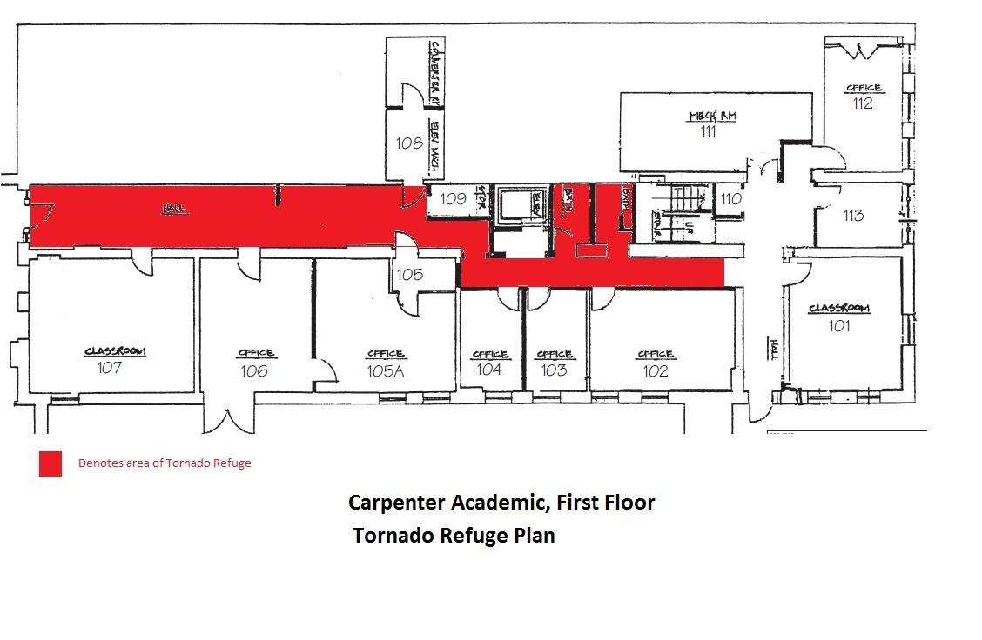
Take shelter on the ground floor in the hallway.
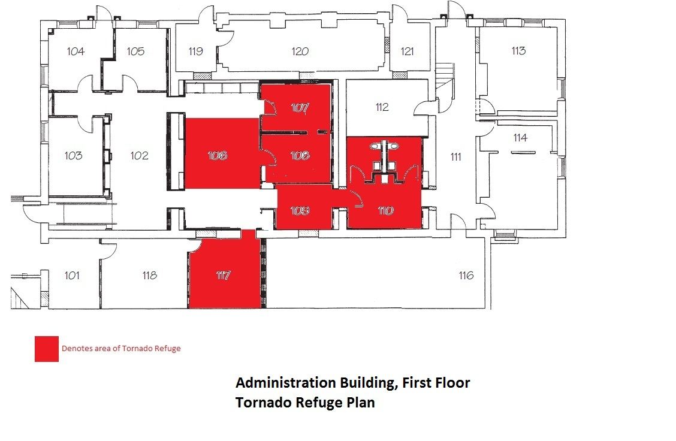
Take shelter on the ground floor inside interior rooms.
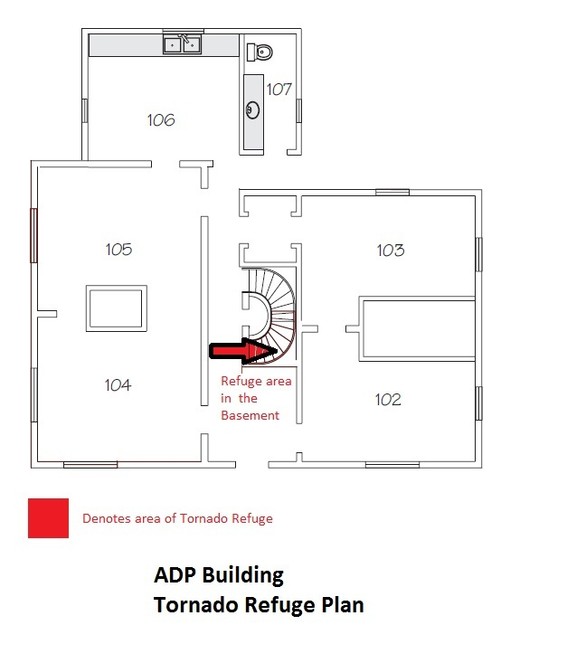

Take shelter inside the basement.

Take shelter inside the basement.
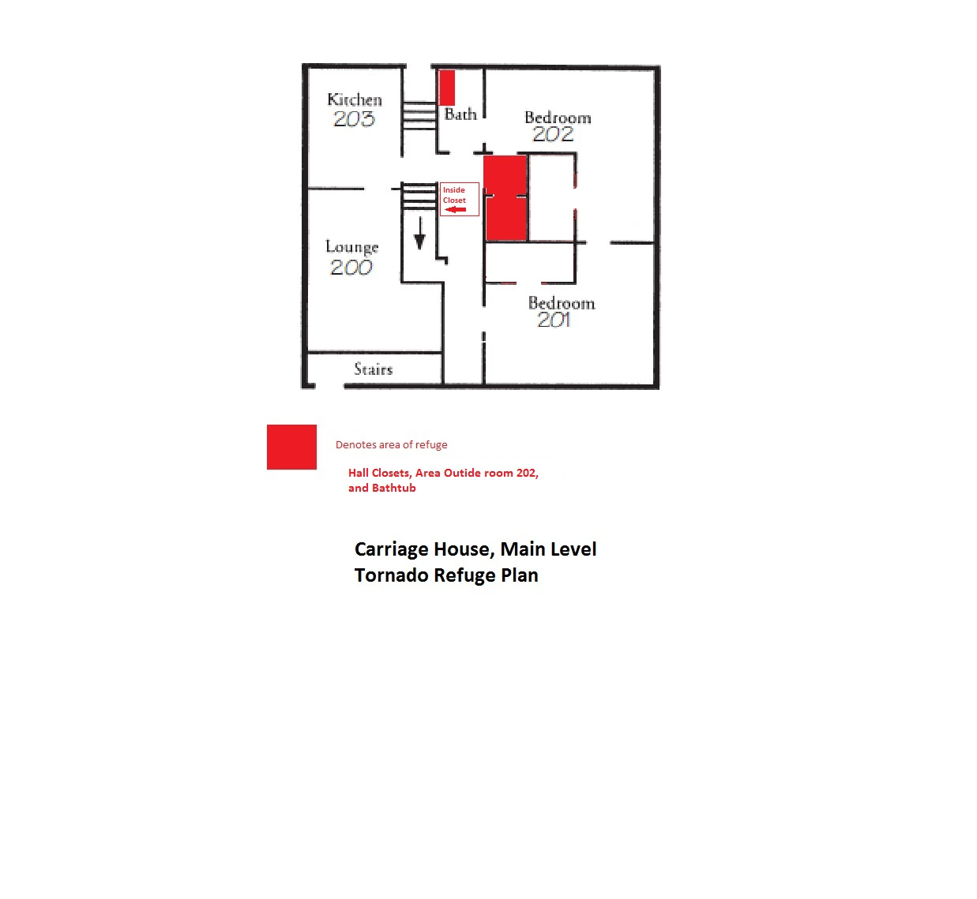
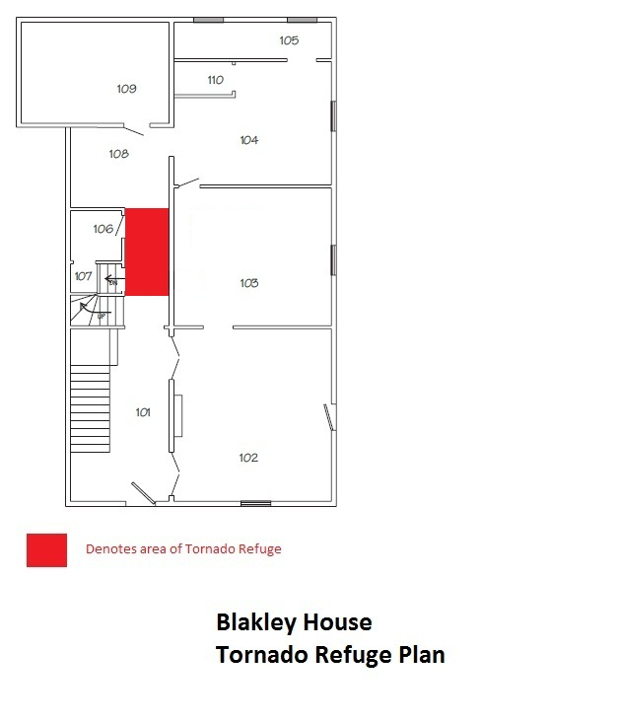
Take refuge on the first floor hallway.

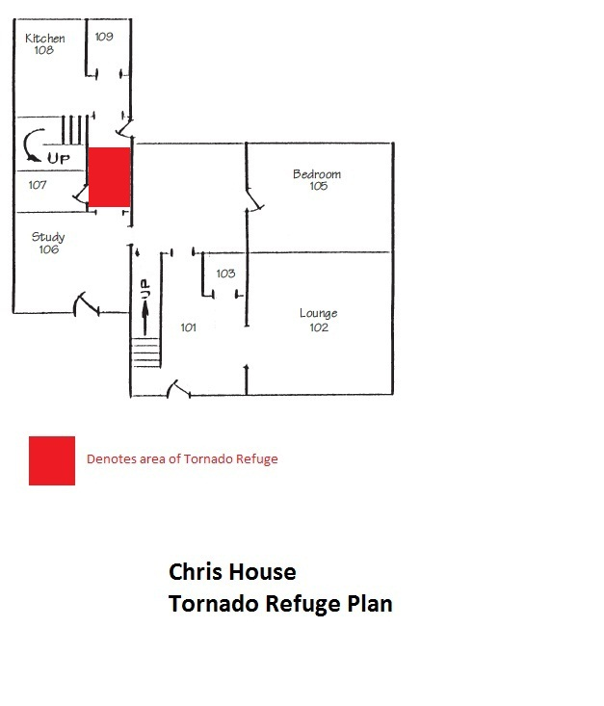
Take refuge on the first floor hallway.
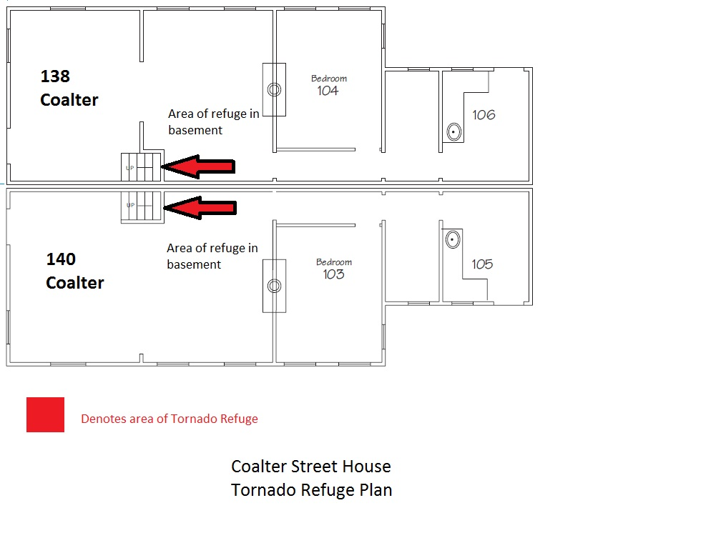 Take refuge inside the basement.
Take refuge inside the basement.
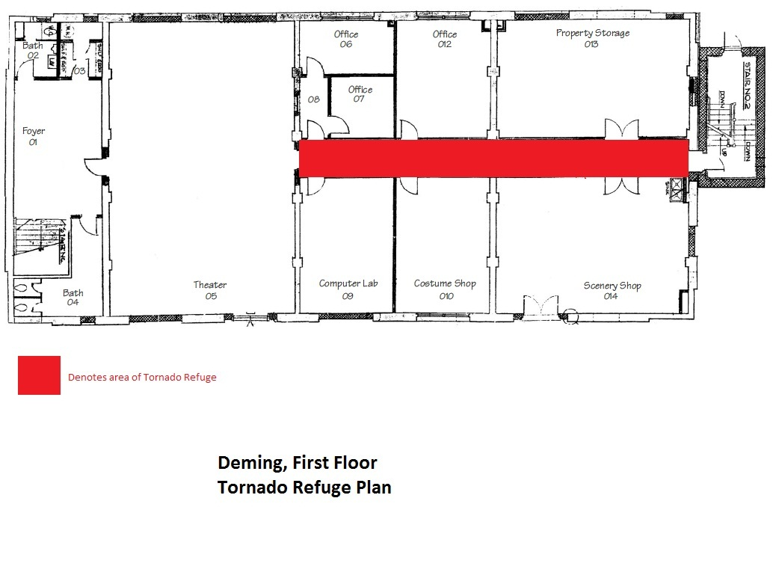
Take refuge on the first floor hallway.

Take refuge inside the basement.
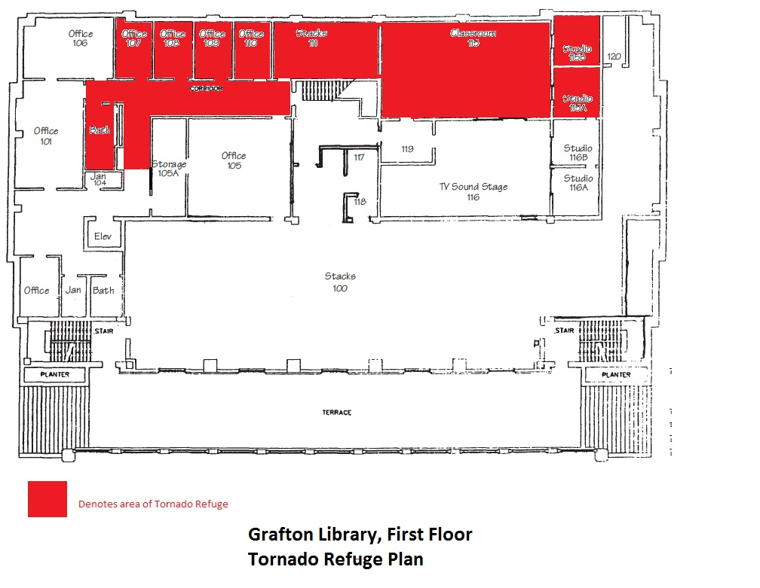
Take refuge inside the first-floor rooms on the north side of the building.
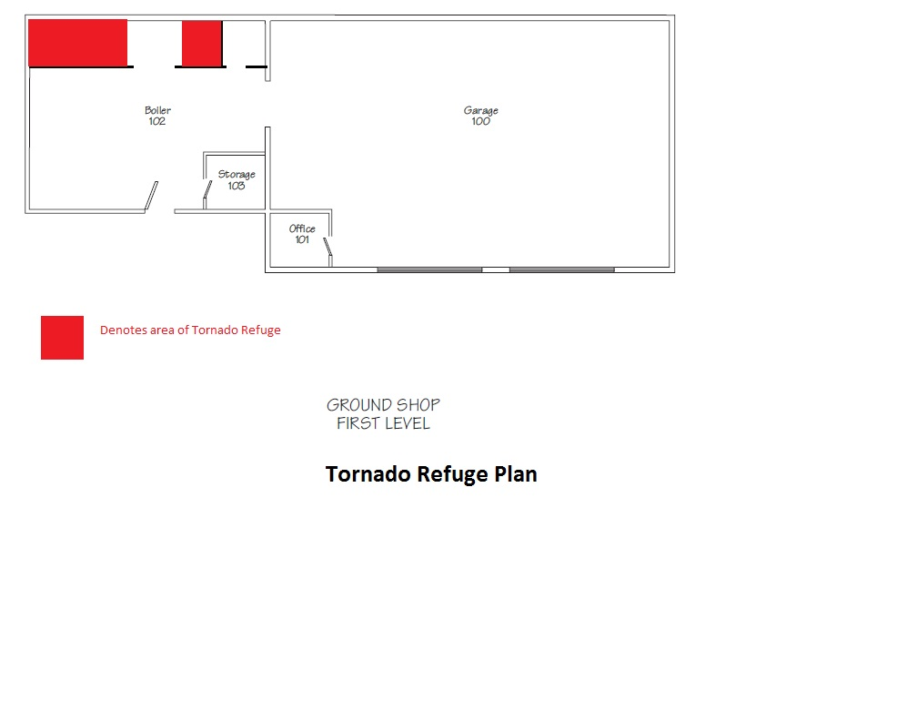
Take refuge on the first floor next to the boiler room.
Take refuge inside the closets on the first floor.
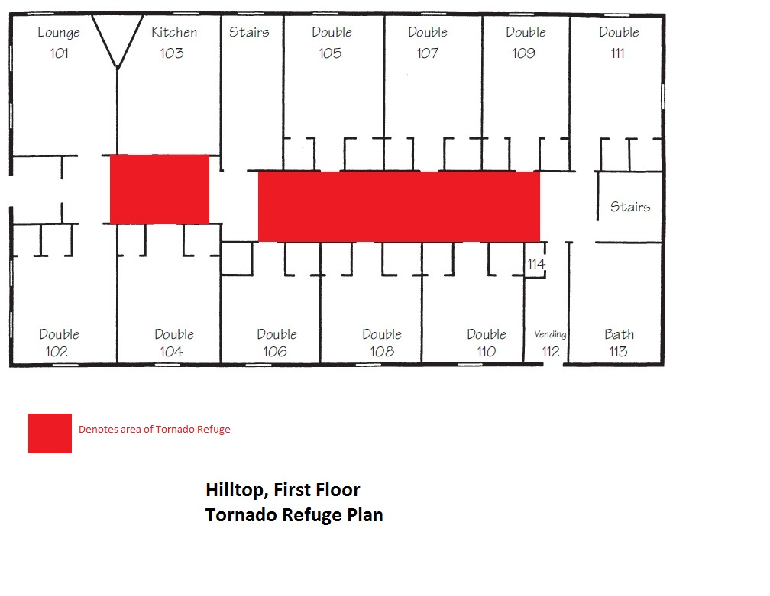
Take refuge in the first-floor hallway.
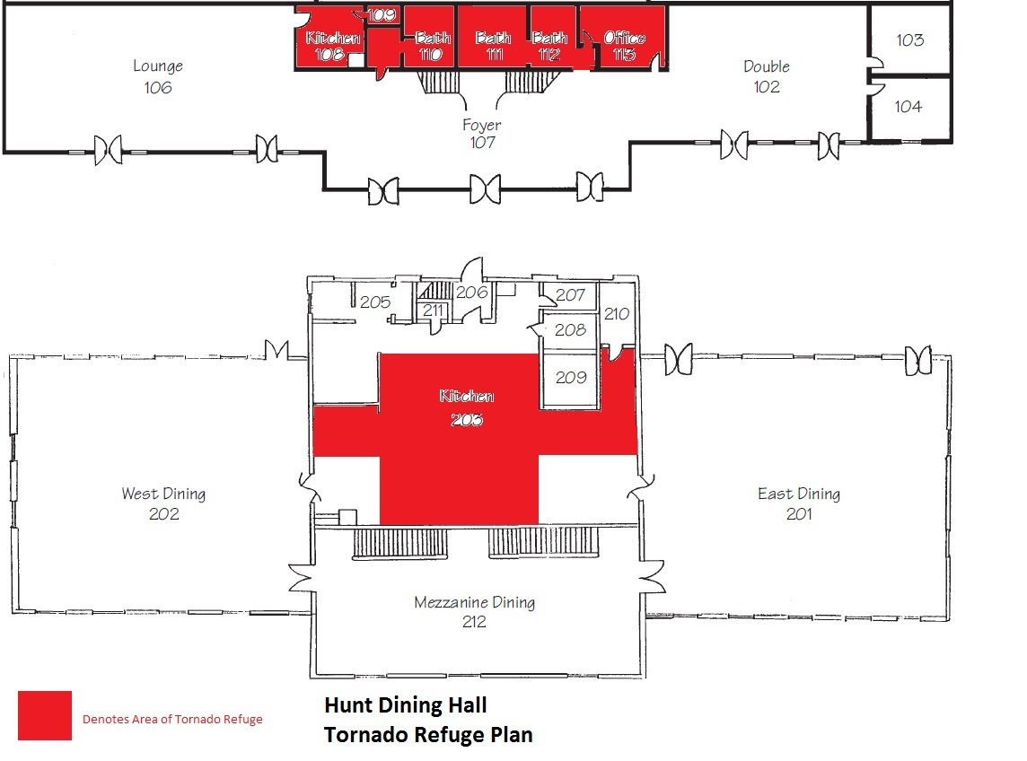
Take refuge either inside the first-floor offices or inside the kitchen on the second floor.
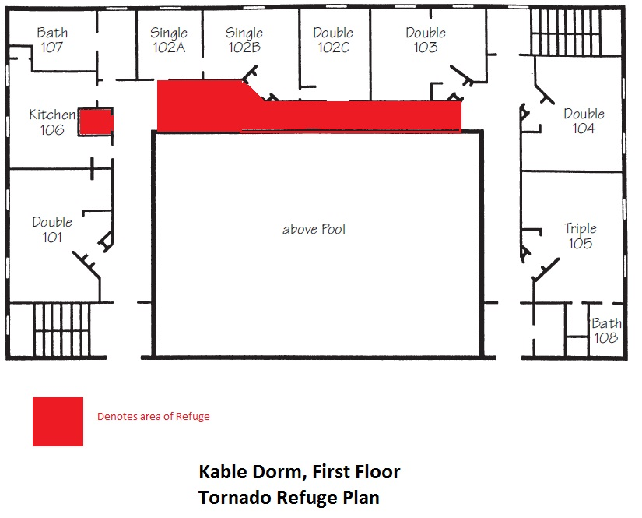
Take shelter in the laundry room or on first-floor hallway outside of rooms 102-A , 102-B, 102-C, and 103.
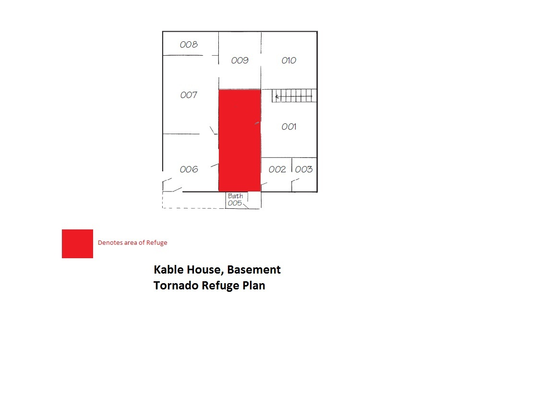
Take refuge inside the basement hallway.
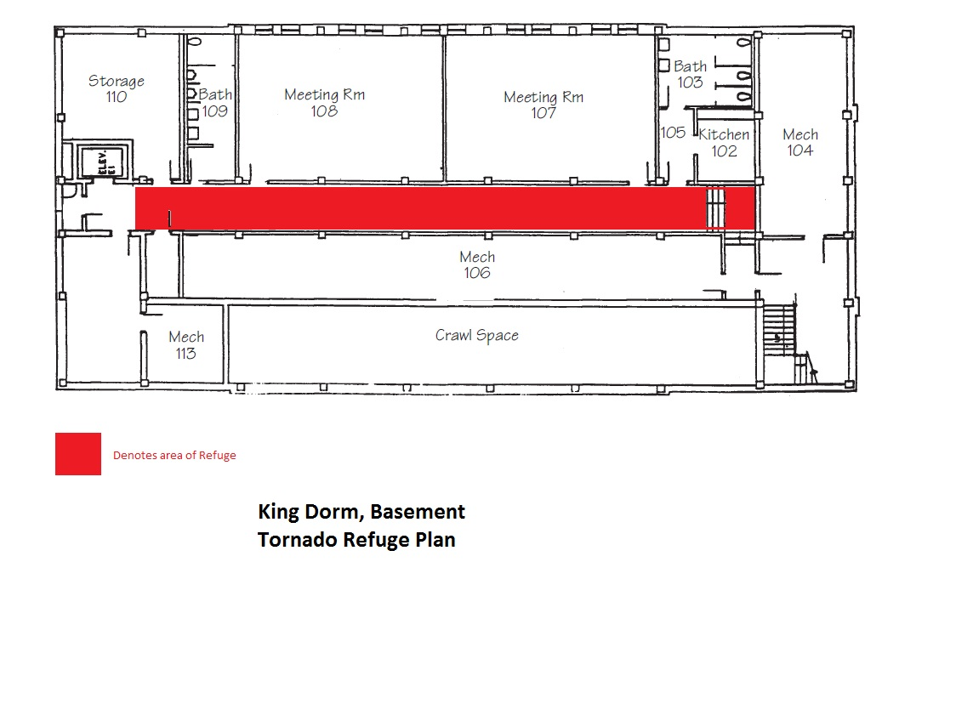

Take refuge inside the basement hallway.
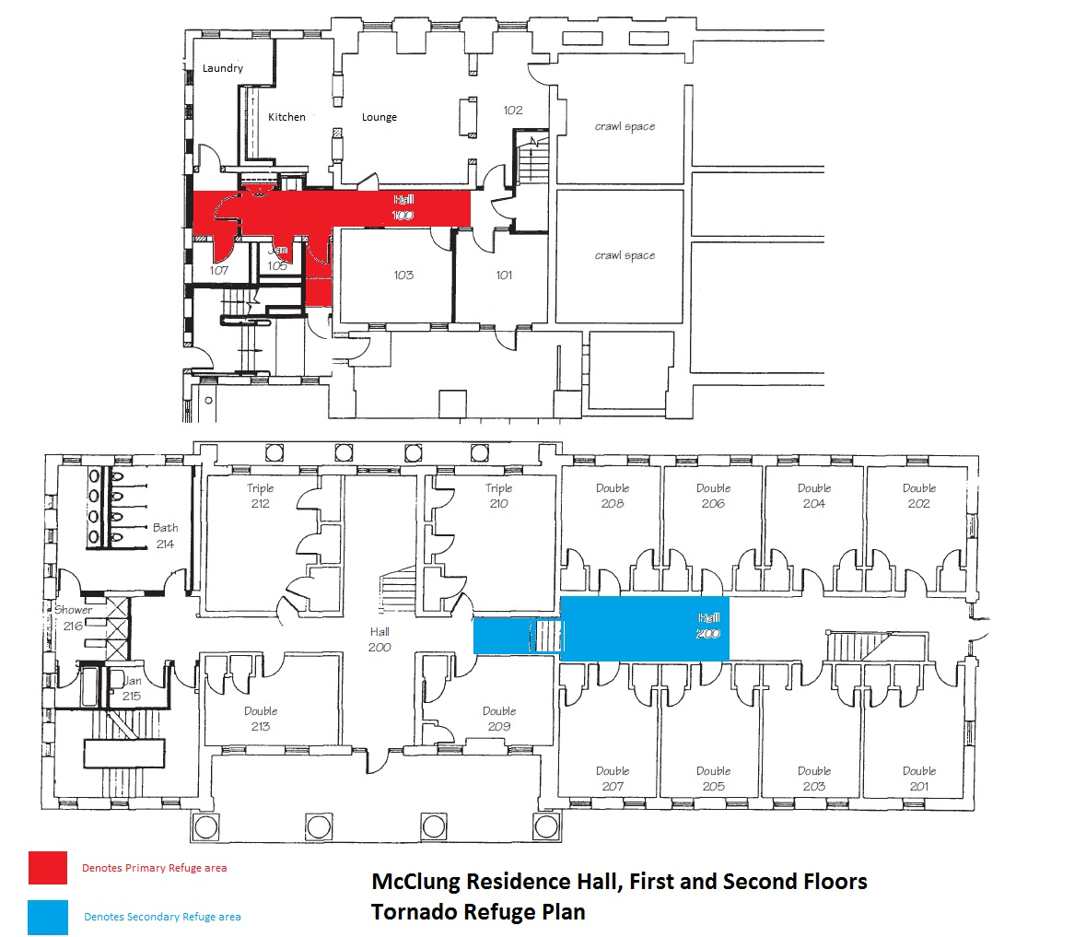
Take refuge inside the basement hallway or in the middle of the second-floor hallway.
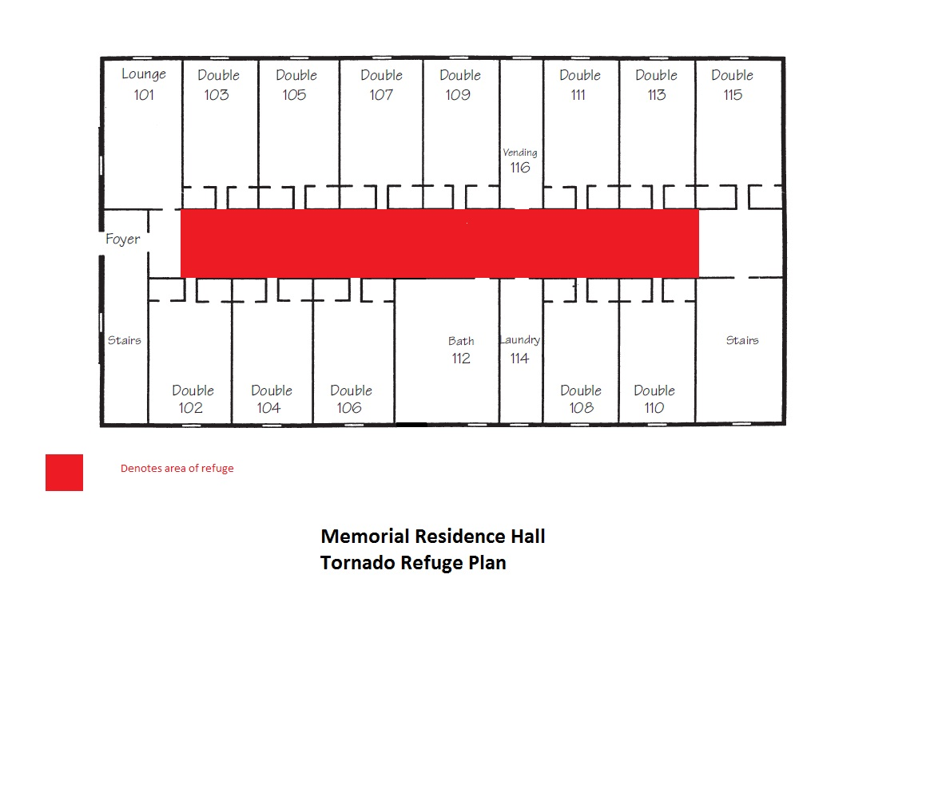
Take shelter inside first-floor hallway.
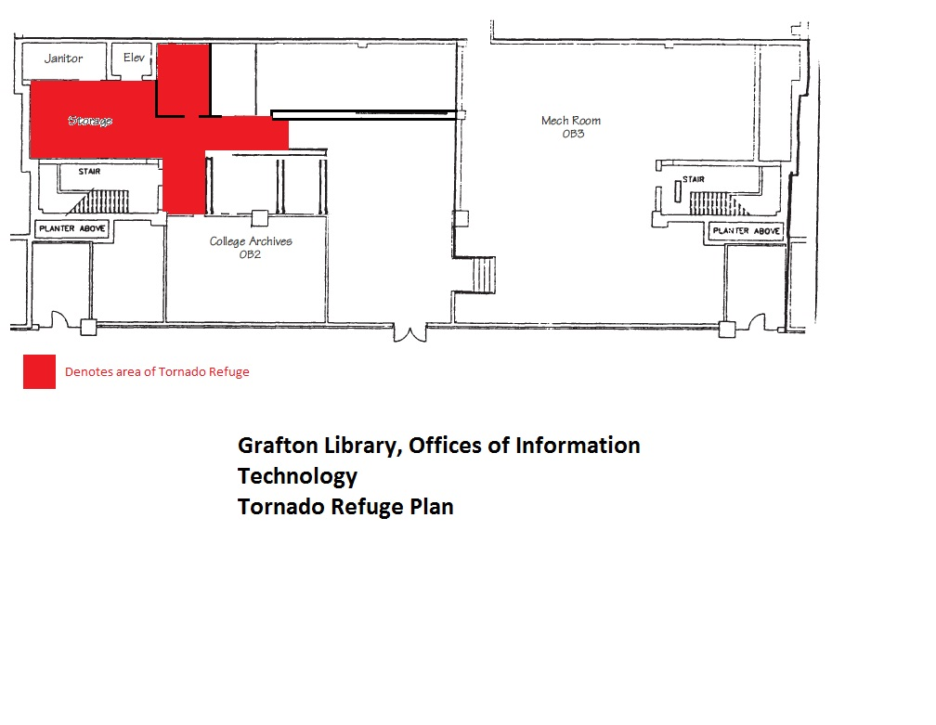
Take refuge inside the storage area next to the stairwell.
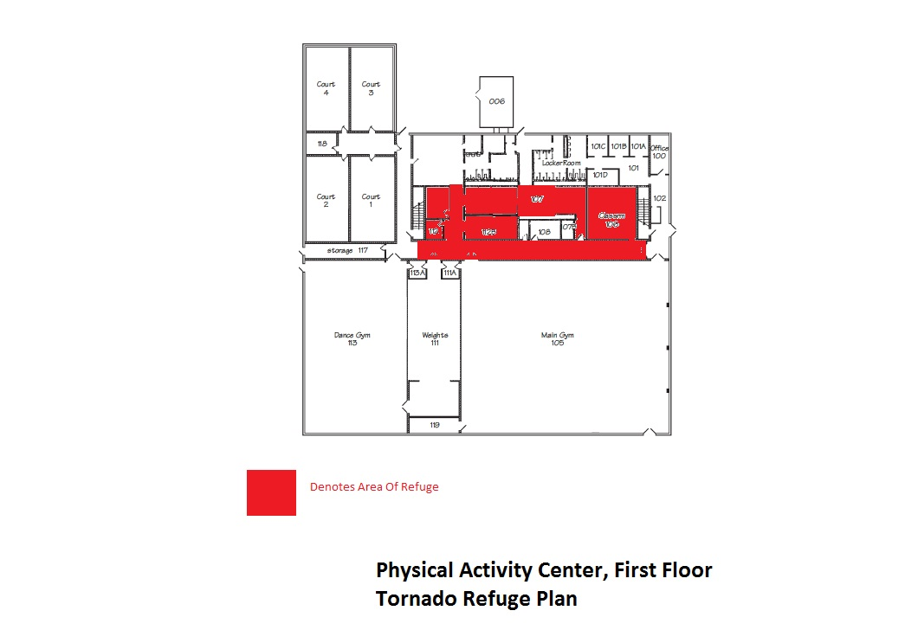

Take refuge inside the main hallway, training room or classroom.
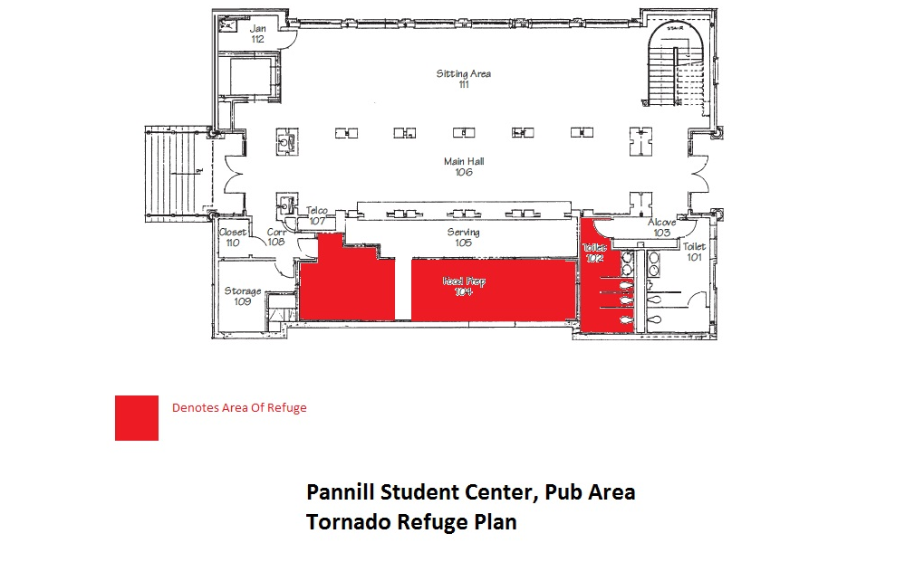

Take refuge inside the meal prep area and inside the women's bathroom.
Take refuge outside the elevator on the first floor or in the vending area.
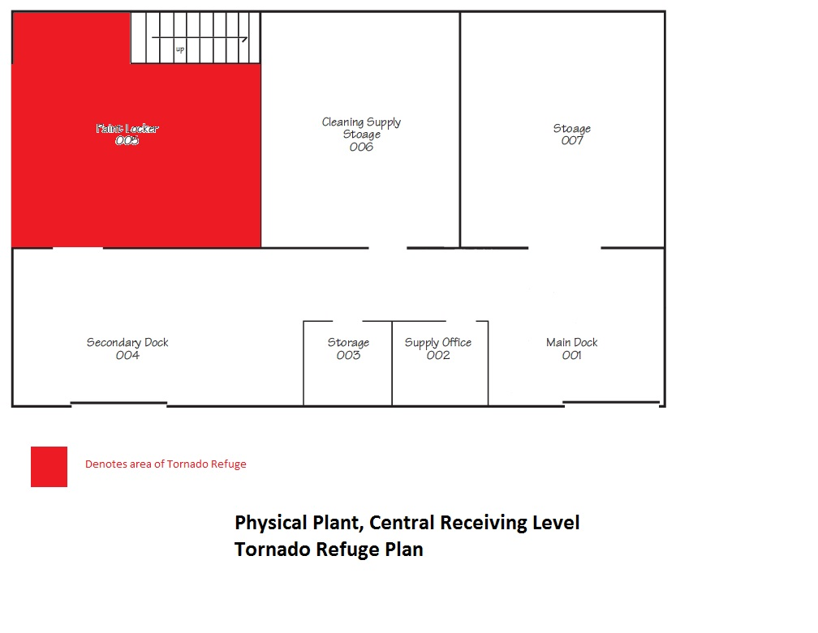
Take refuge inside the paint locker on the Central Receiving Level.
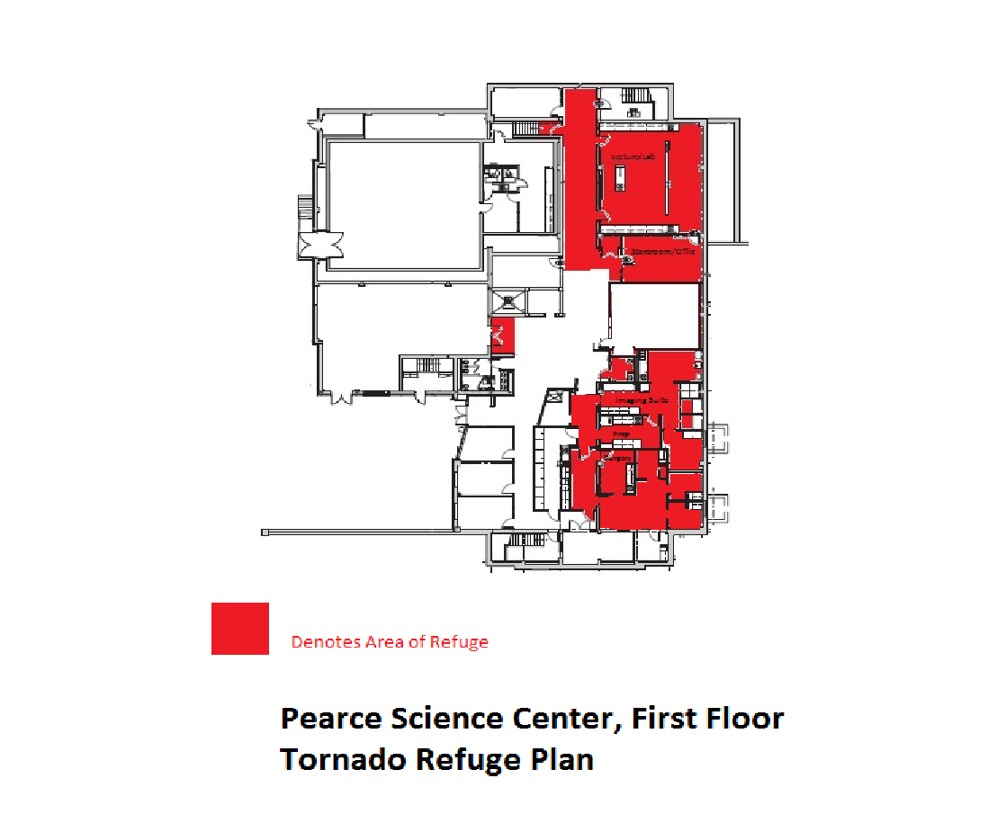

Take shelter in the labs or rooms on the eastern side of the first floor.
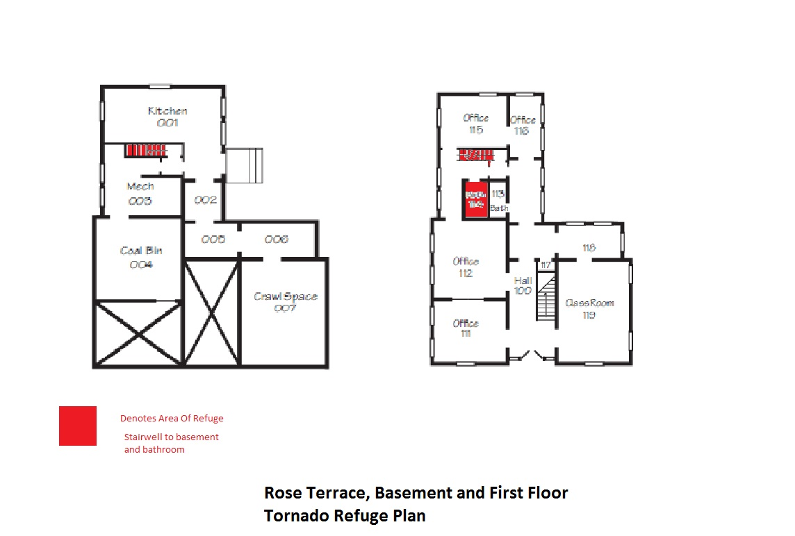
Take refuge in the back stairwell of the basement and first floor.
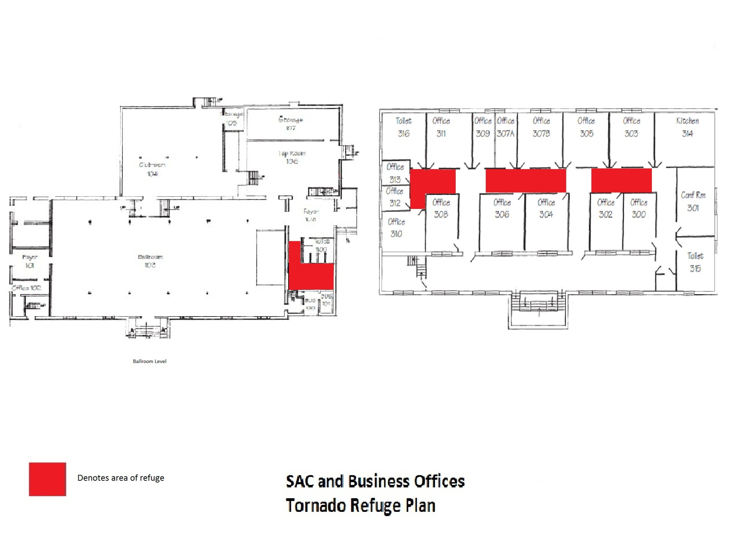
On the third floor, take refuge in the interior hallway; on the ballroom level, take refuge in the men’s bathroom.
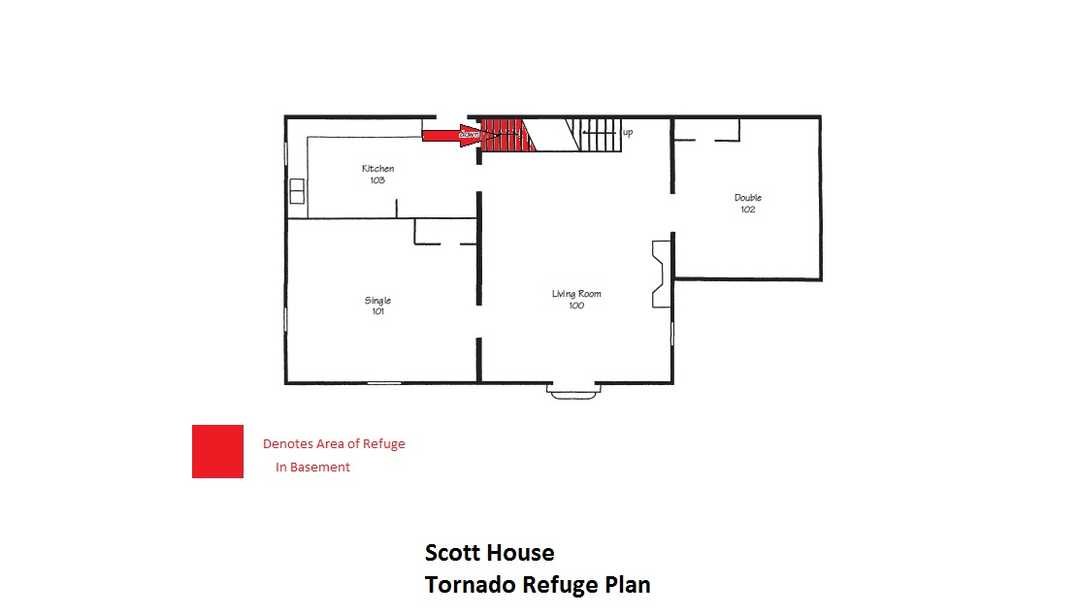
Take refuge in the stairwell to the basement.

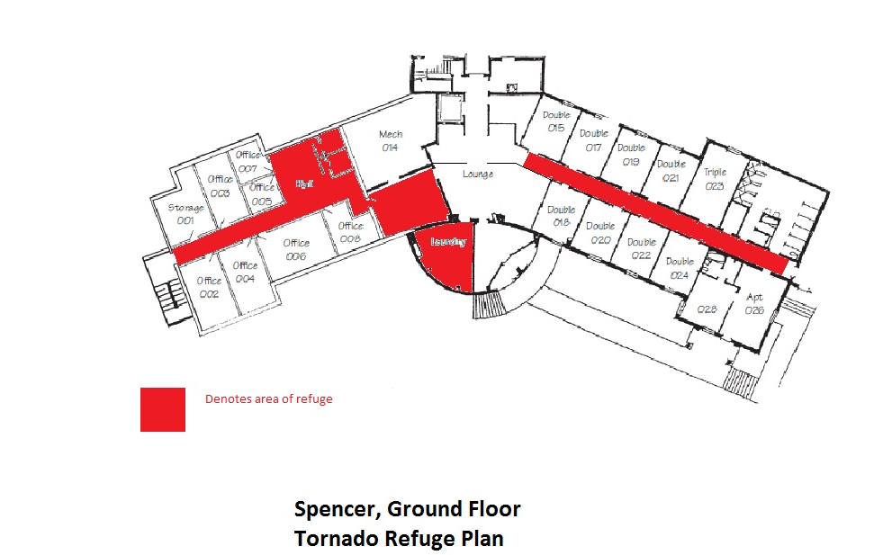
Take refuge in the interior hallway and laundry are of the ground floor.
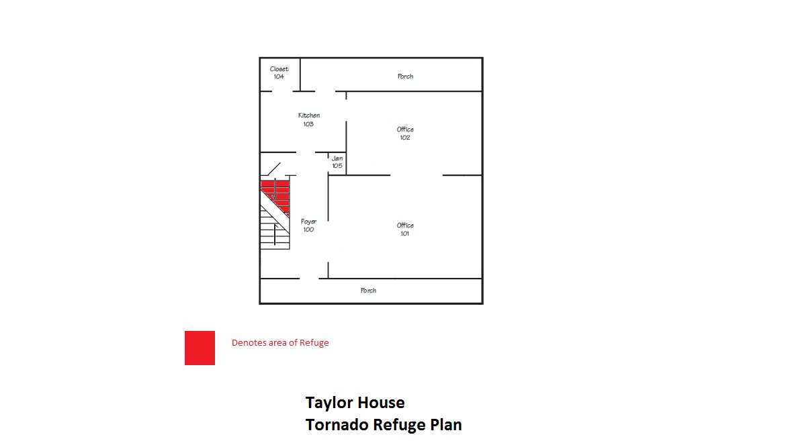
Take refuge in the basement.
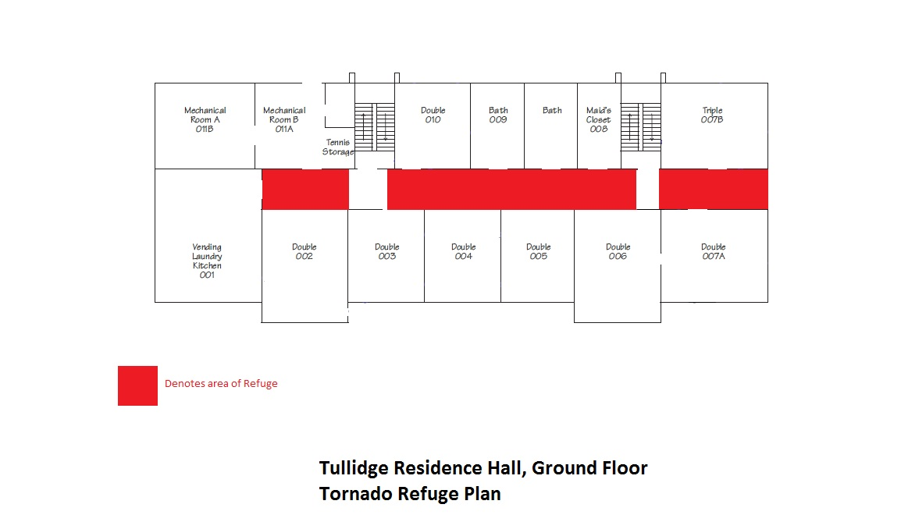

Take refuge in the interior hallway of the ground floor.
Take refuge in the in the basement.

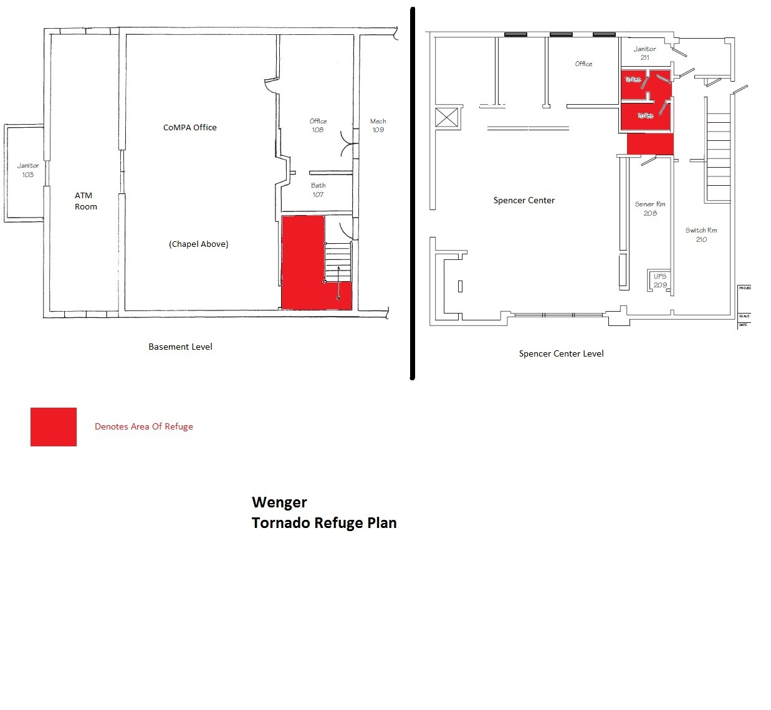
Take refuge in the back hallway and bathrooms on the Spencer Center level or behind the stairwell on the basement level.
Take refuge in the first-floor bathroom, laundry room, and hallway.
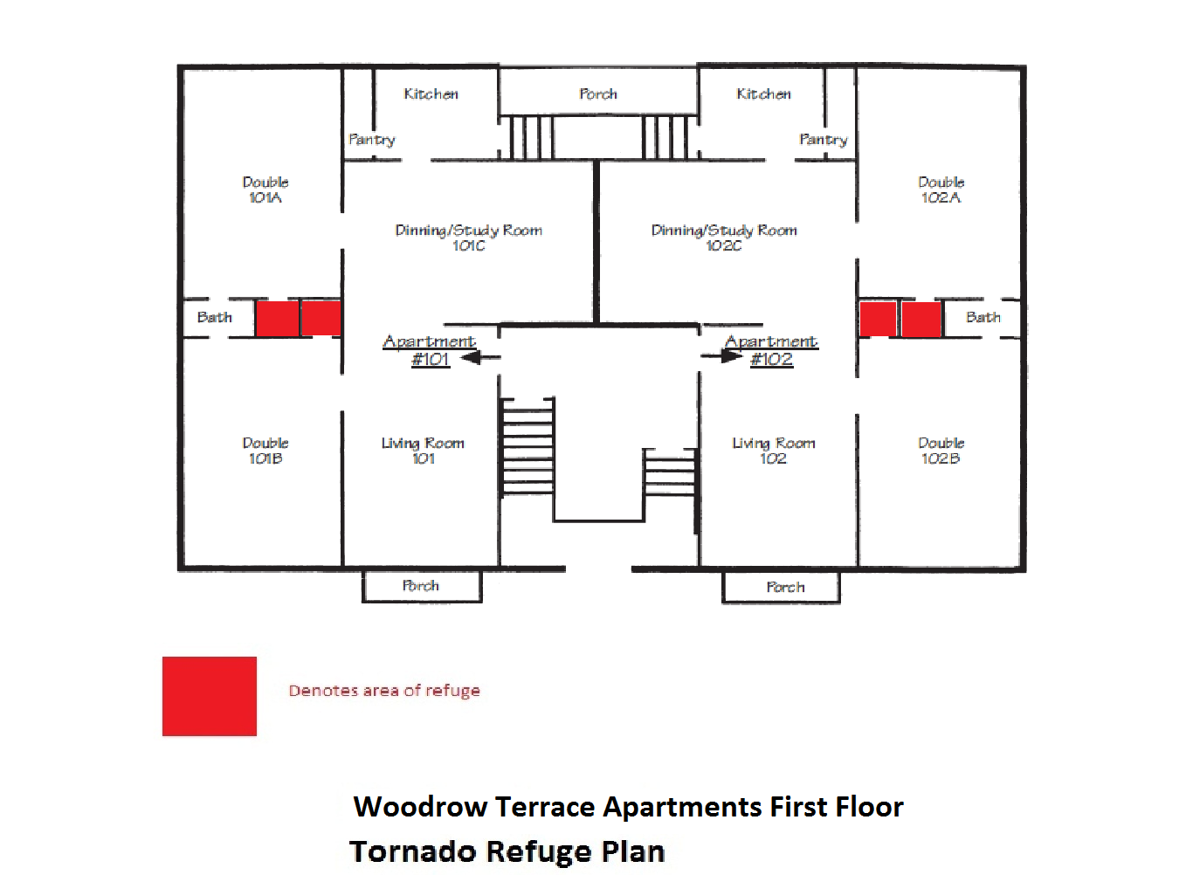
Take refuge in the closets of rooms 101-A, 101-B, 102-A and 102-B.
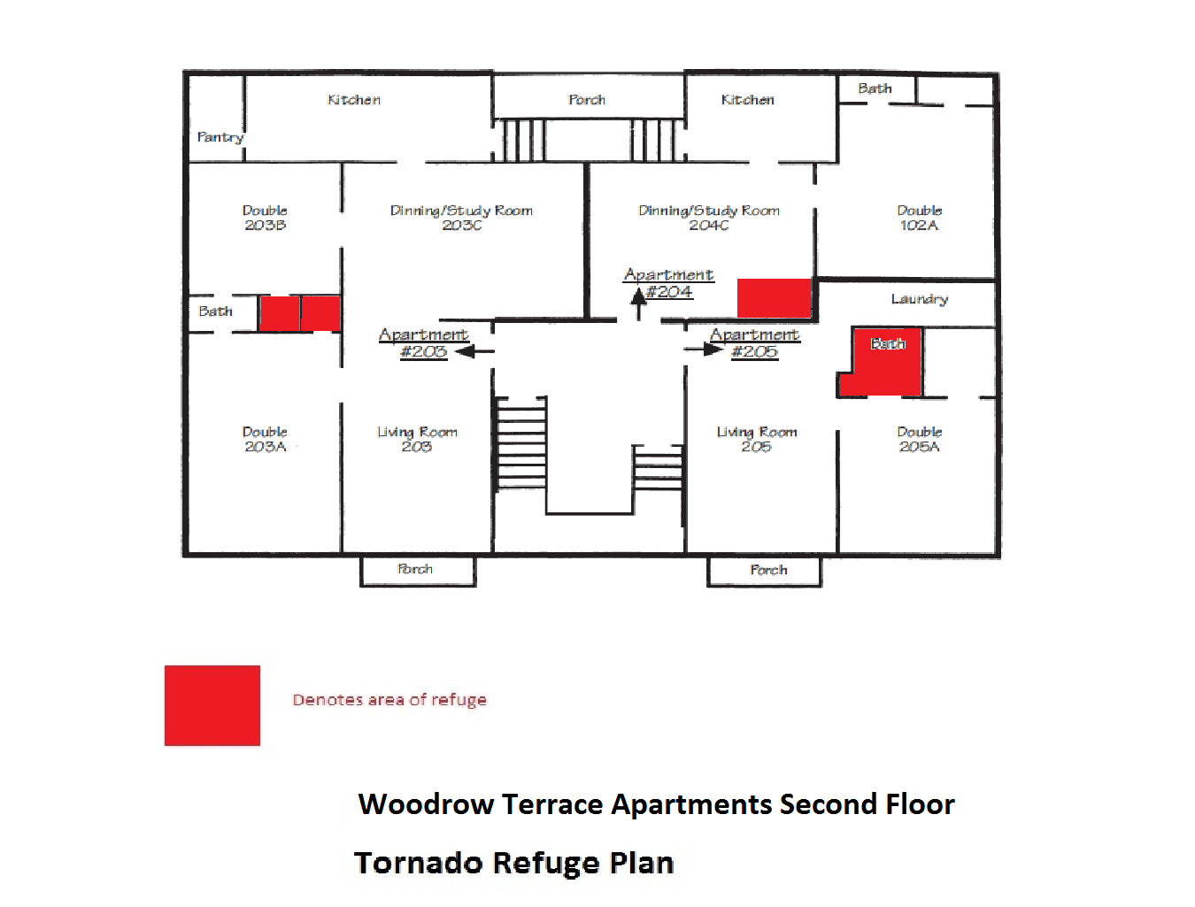
Take refuge in the closets in rooms 203-A and 203-B and inside the bathroom of 205-A.
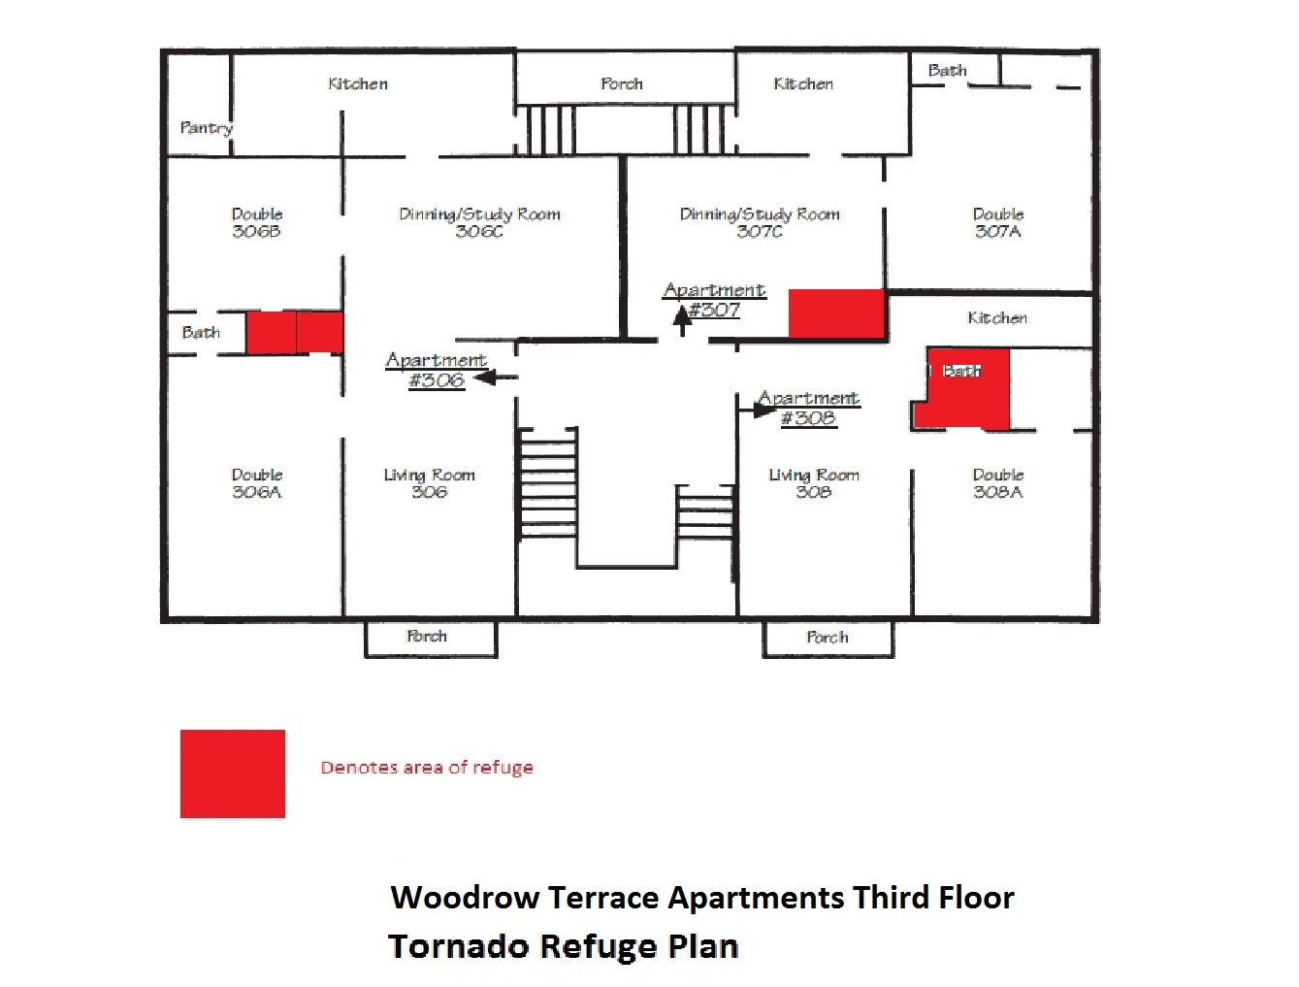
Take refuge in the bathrooms of rooms 306-A and 306-B and in the bathroom of room 308-A.

